**“AITor” - EDUCATION PLATFORM – A PERSONALIZED STUDENT PERFORMANCE ANALYZER AND RECOMMENDATION SYSTEM**

2022-017

Project Status Document - 2

Hirimuthugoda UJ– IT19138114

B.Sc. (Hons) in Information Technology specializing in Software Engineering

Department of Software Engineering

Sri Lanka Institute of Information Technology

Sri Lanka

January 2022

# DECLARATION

We declare that this is our own work, and this proposal does not incorporate without acknowledgement any material previously submitted for a degree or diploma in any other university or Institute of higher learning and to the best of our knowledge and belief it does not contain any material previously published or written by another person except where the acknowledgement is made in the text.

|  |  |  |
| --- | --- | --- |
| Name | Student ID | Signature |
| Hirimuthugoda UJ | IT19138114 |  |

The above candidates are carrying out research for the undergraduate Dissertation

under my supervision.

Date:

11/13/2022

Contents

DECLARATION ii

1. Microsoft Teams chats and Meetings with supervisor/co-supervisor/external supervisor 6

Initial Teams group for research team – continuous communication 6

1.1. Research team members only MS teams’ continuous communication 7

2. WhatsApp Chat Group for Continuous Communication with Team Members with Supervisor/Co-Supervisor/External Supervisor. 9

2.1. Continuous Commination through WhatsApp Chat Group 9

3. Scheduled MS Teams discussions 16

3.1. Weekly meeting with team members 16

3.2. Bi-Weekly meeting with Co-Supervisor/External-Supervisor for research progress evaluation 17

4. Research Paper Presentations 19

4.1. IEEE UEMCON 2022 19

5. Project planner 21

5.1. Boards 21

5.2. Charts 23

5.2.1. Overall Project Task Overview 23

5.2.2. Overview of Tasks Of Hirimuthugoda UJ (IT19138114) 25

6. Project Gantt chart 26

7. Work breakdown chart 27

User task allocation details 28

Allocated task 29

Predicted time 29

Actual time spent 29

1. Career paths and required skills Dataset creation 29

01/04/2022 – 30/04/2022 (30 days) 29

20 days 29

2. Career path recommendation model implementation 29

15/04/2022 – 30/04/2022 (10 days) 29

18 days 29

3. Career path recommendation API implementation 29

01/05/2022 – 06/05/2022 (5 days) 29

2 day 29

4. Job opportunity recommendation engine implementation 29

30/04/2022 – 11/05/2022 (10 days) 29

8 days 29

5. Skill extraction algorithm implementation 29

05/04/2022 – 05/04/2022 (10 days) 29

9 days 29

6. Career path identification model - DAL integration 29

25/06/2022 – 30/06/2022 (5 days) 29

2 days 29

7. Student skill identification module implementation 29

30/06/2022 – 15/07/2022 (15 days) 29

12days 29

8. skill identification module, career path identification module and job opportunity recommendation module integration 29

01/06/2022 – 01/07/2022 (30 days) 29

30 days 29

9. career path identification model evaluation 30

20/07/2022 – 31/07/2022 (21 days) 30

25 days 30

10. Frontend Implementation 30

15/07/2022 – 30/08/2022 (45 days) 30

40 days 30

11. Unit Testing 30

15/08/2022 – 30/08/2022 (15 days) 30

16 Days 30

12. Overall System Integration 30

01/09/2022 – 20/09/2022 (20 days) 30

30 days 30

8. GitLab Charts 30

8.1. Commits To Master Branch 30

8.2. Commits By Hirimuthugoda UJ 31

8.3. Commits To dev/it19138114 33

# Microsoft Teams chats and Meetings with supervisor/co-supervisor/external supervisor

## Initial Teams group for research team – continuous communication

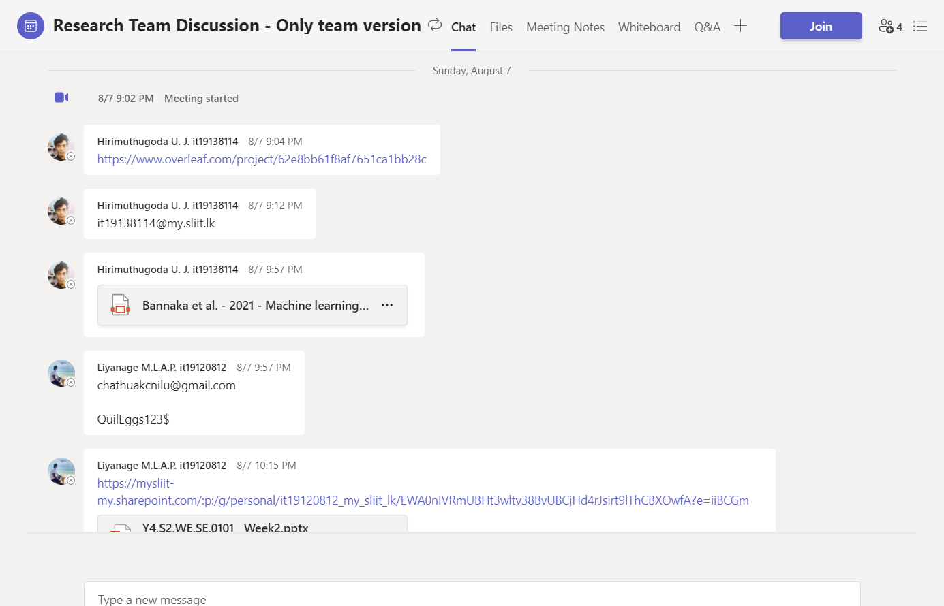

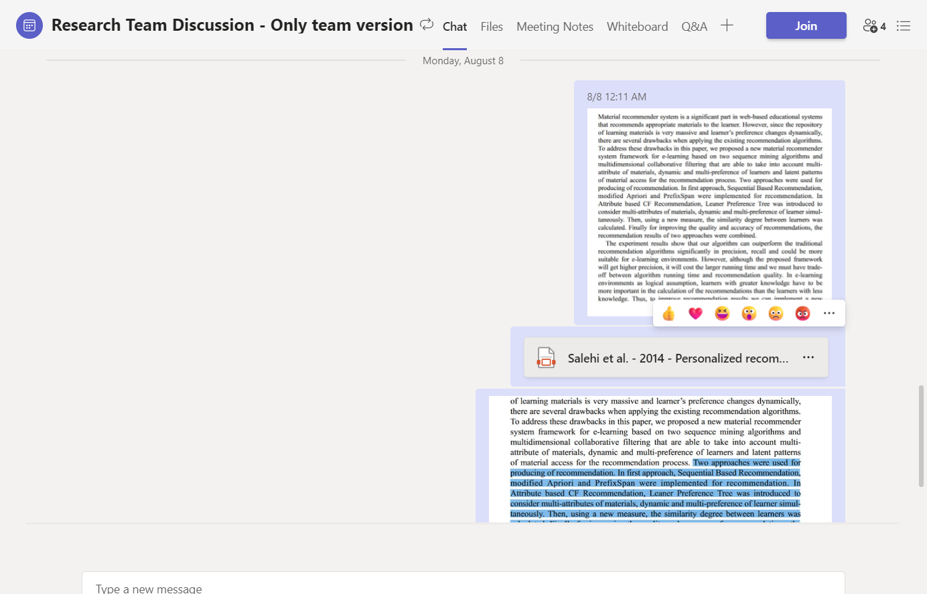

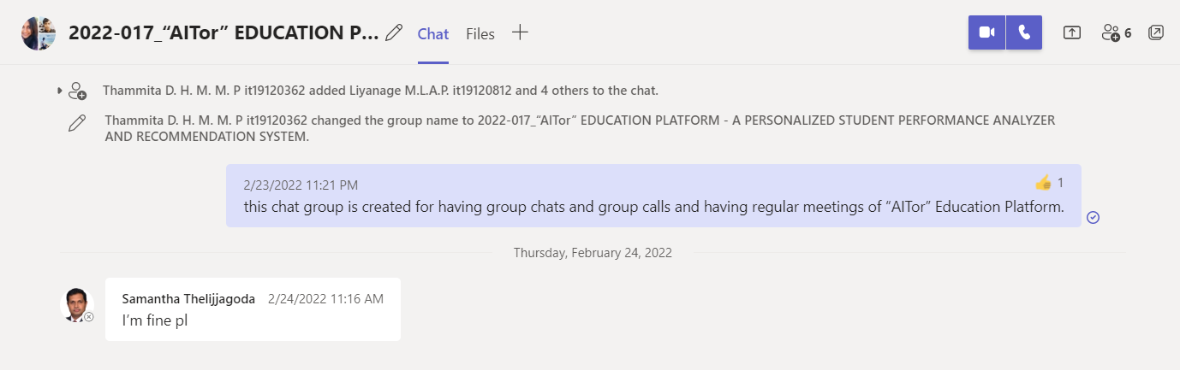

Figure :: Microsoft Teams , Team Creation for meetings with Supervisor/Co-Supervisor/External Supervisors

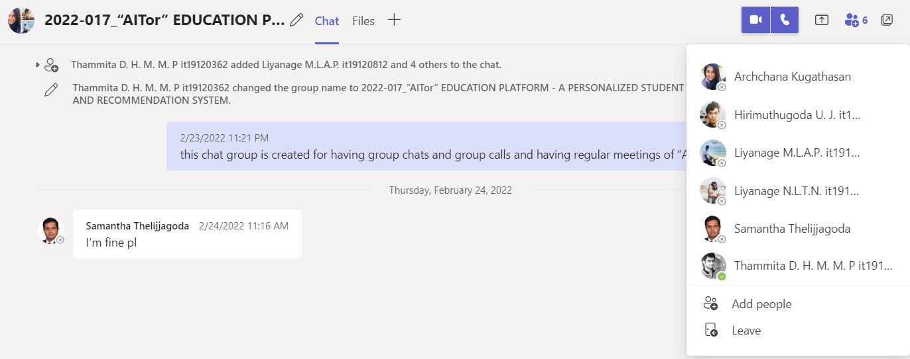

## Research team members only MS teams’ continuous communication

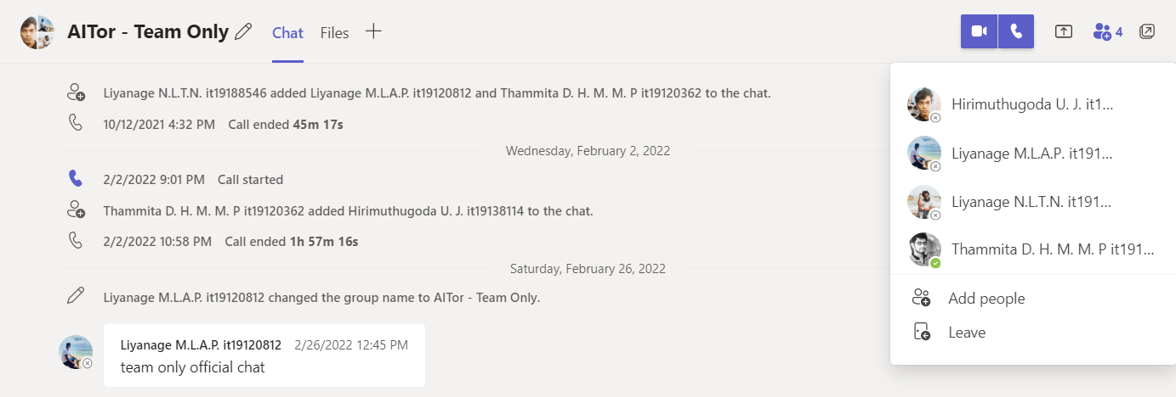

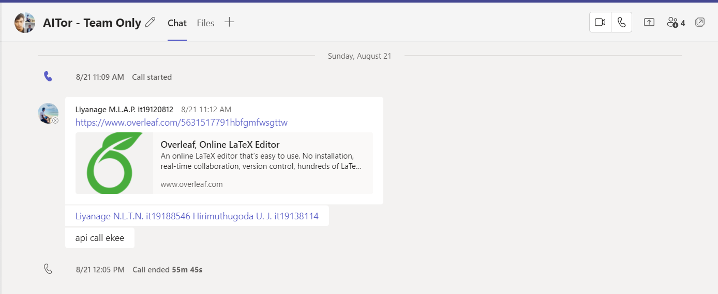

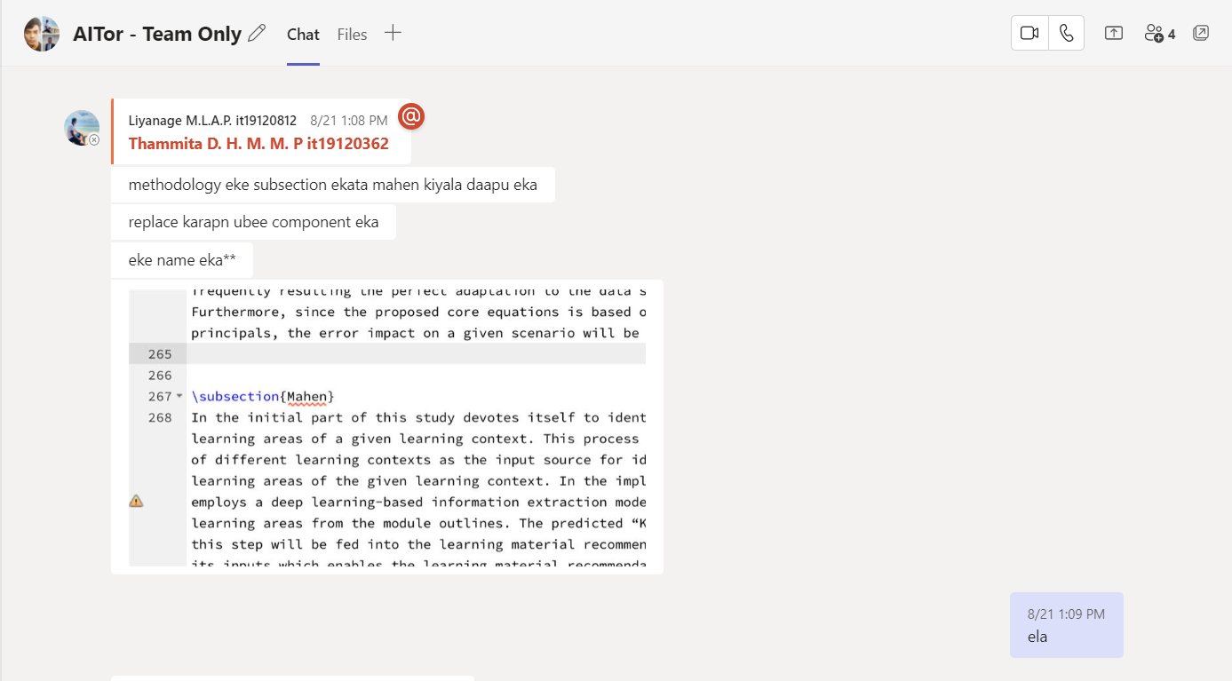

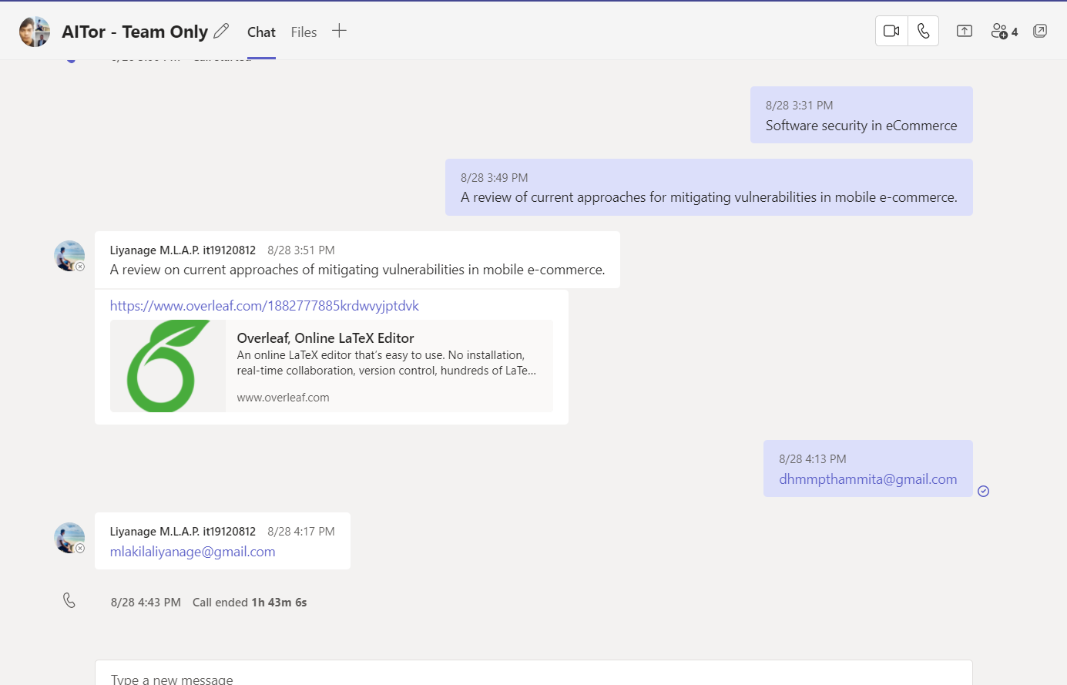

# WhatsApp Chat Group for Continuous Communication with Team Members with Supervisor/Co-Supervisor/External Supervisor.

## Continuous Commination through WhatsApp Chat Group

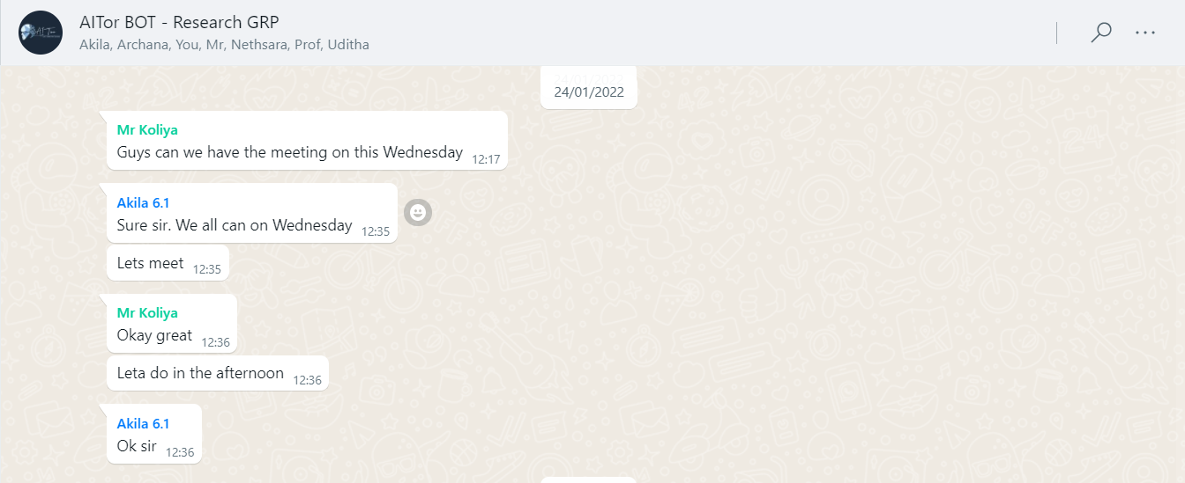

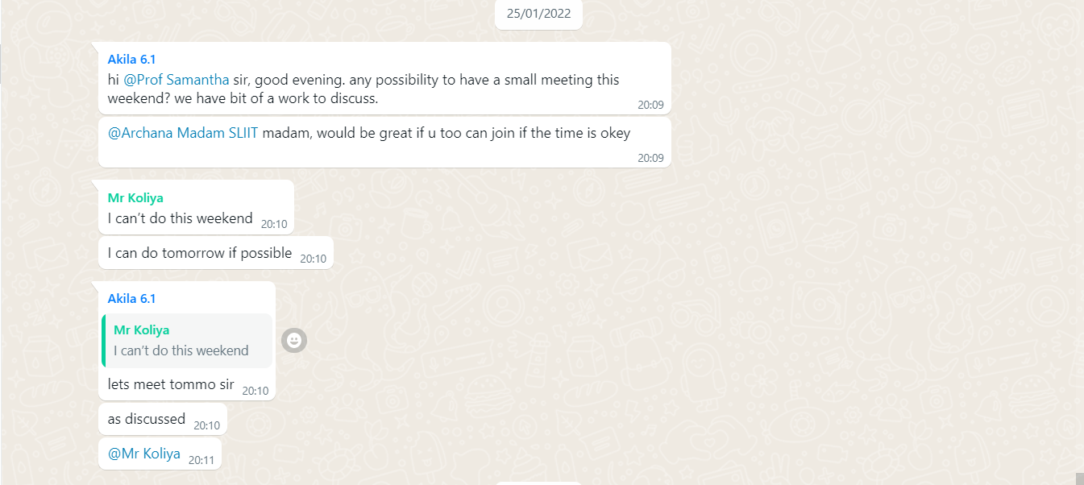

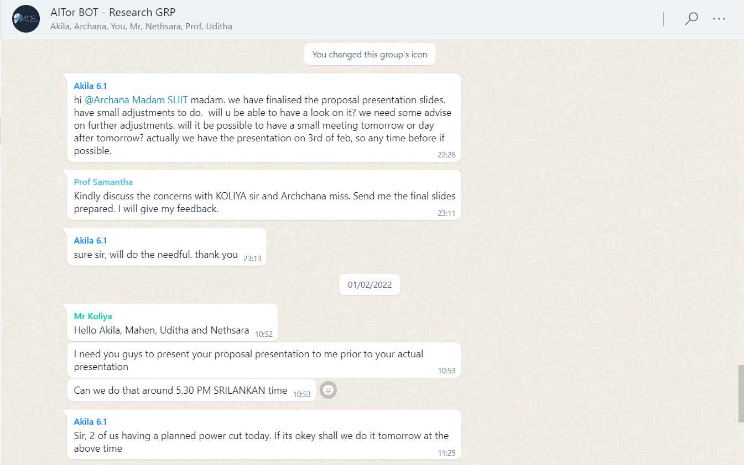

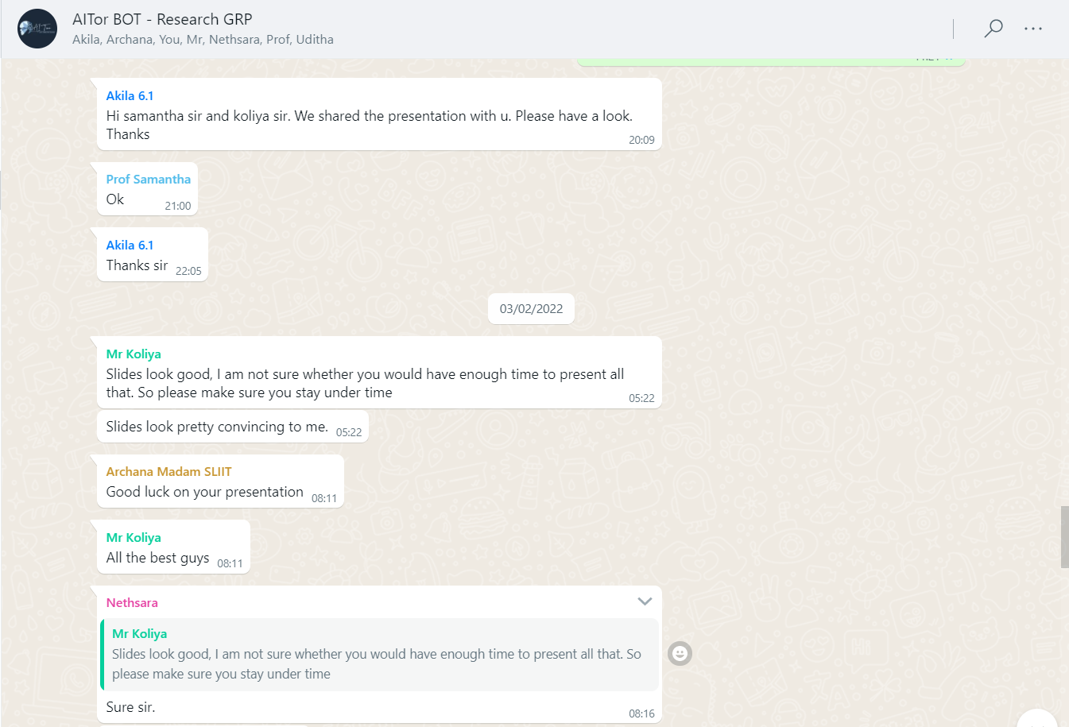

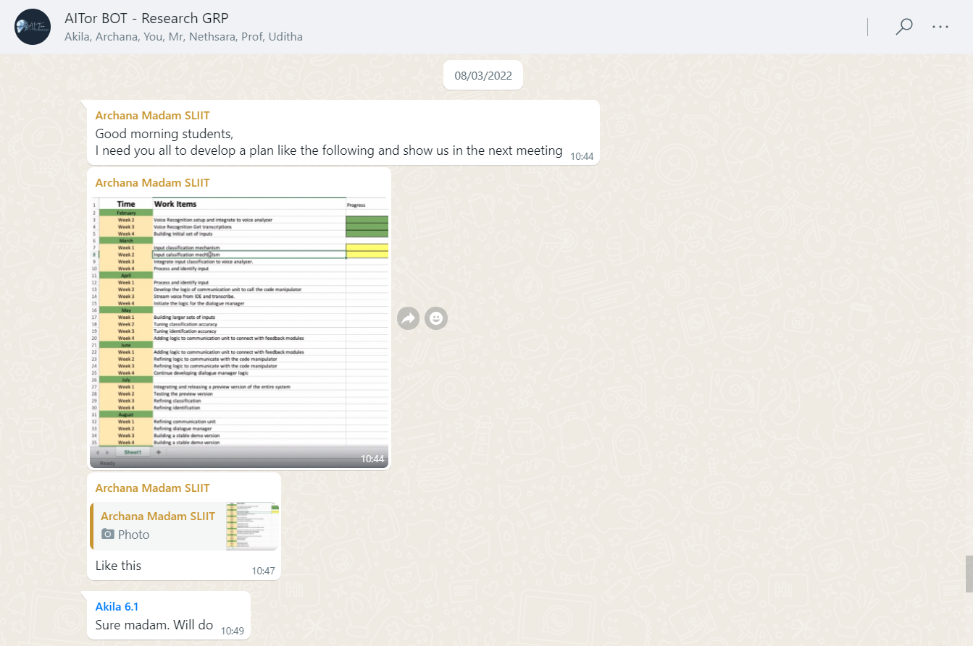

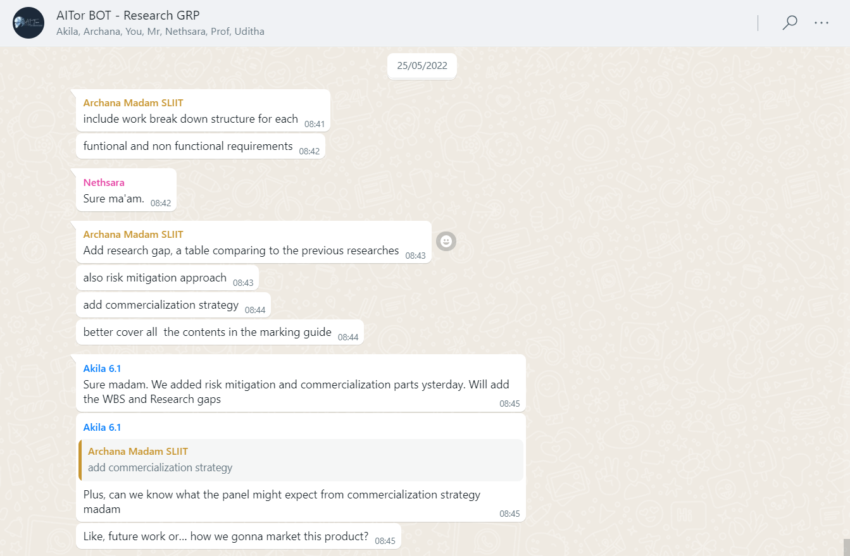

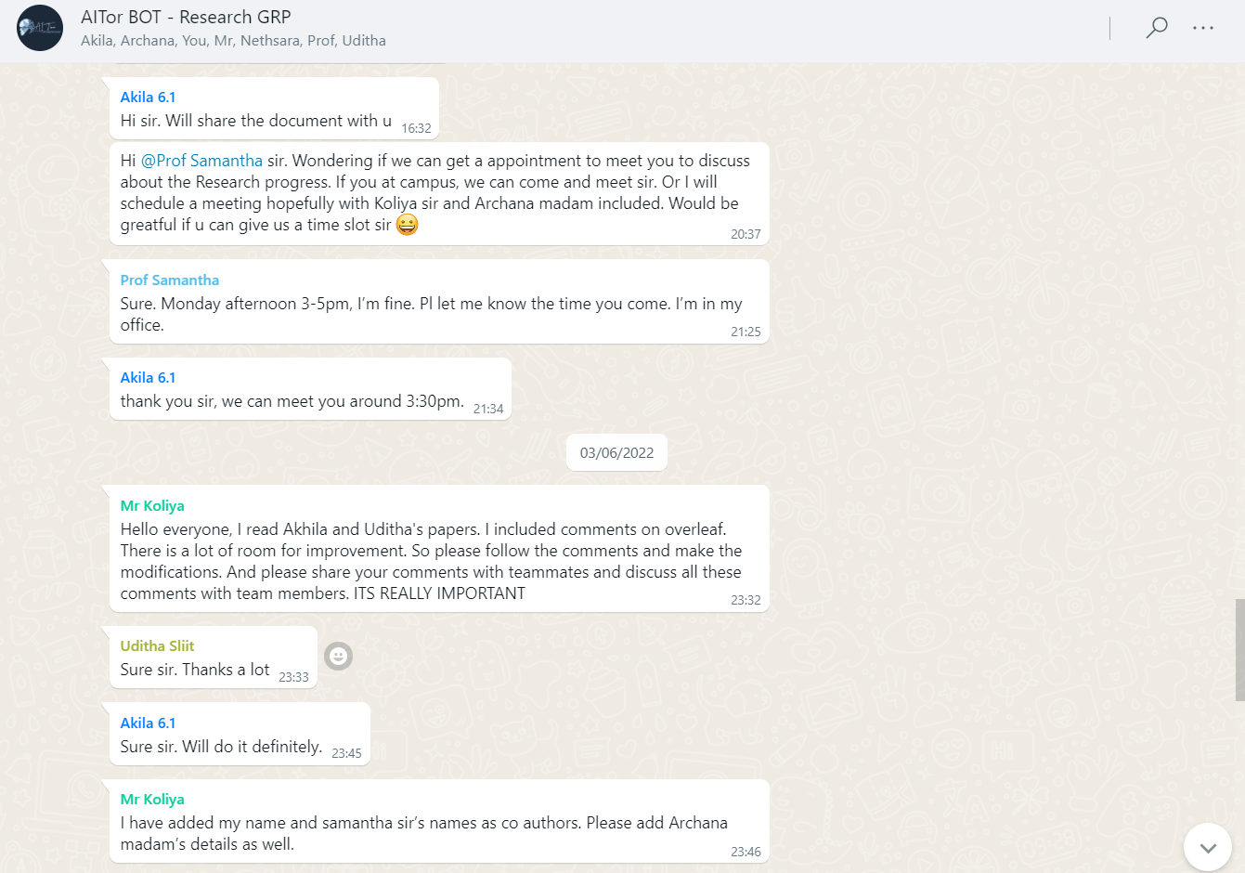

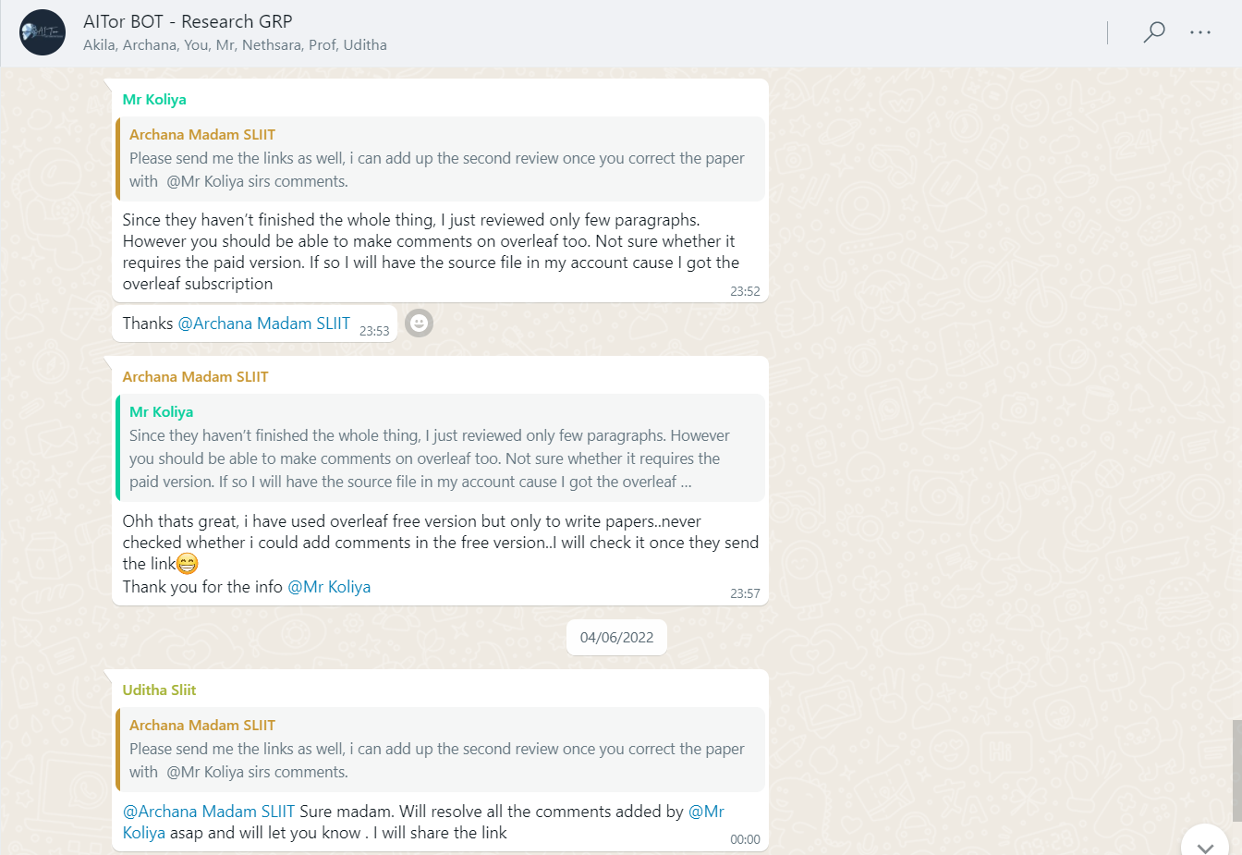

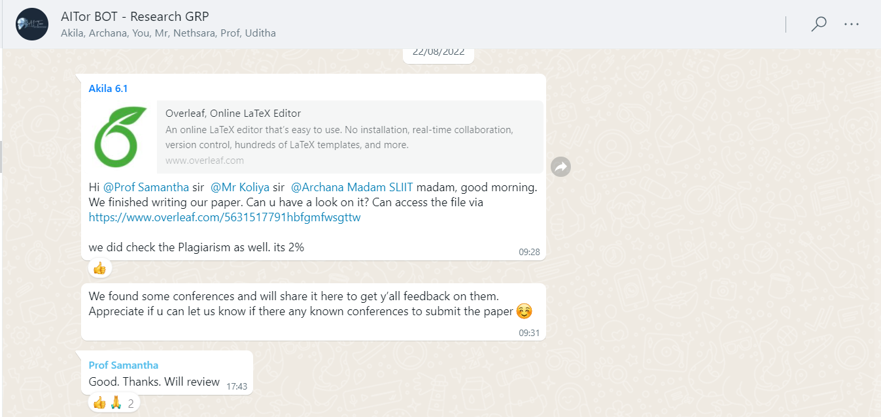

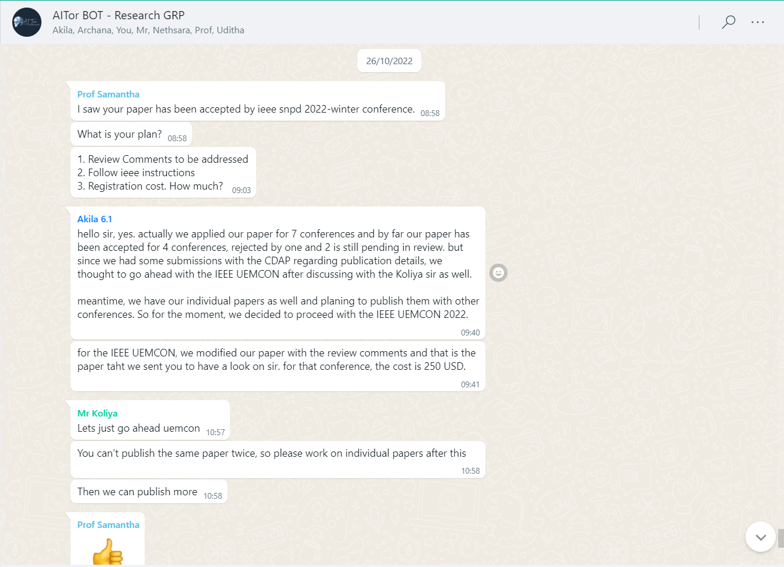

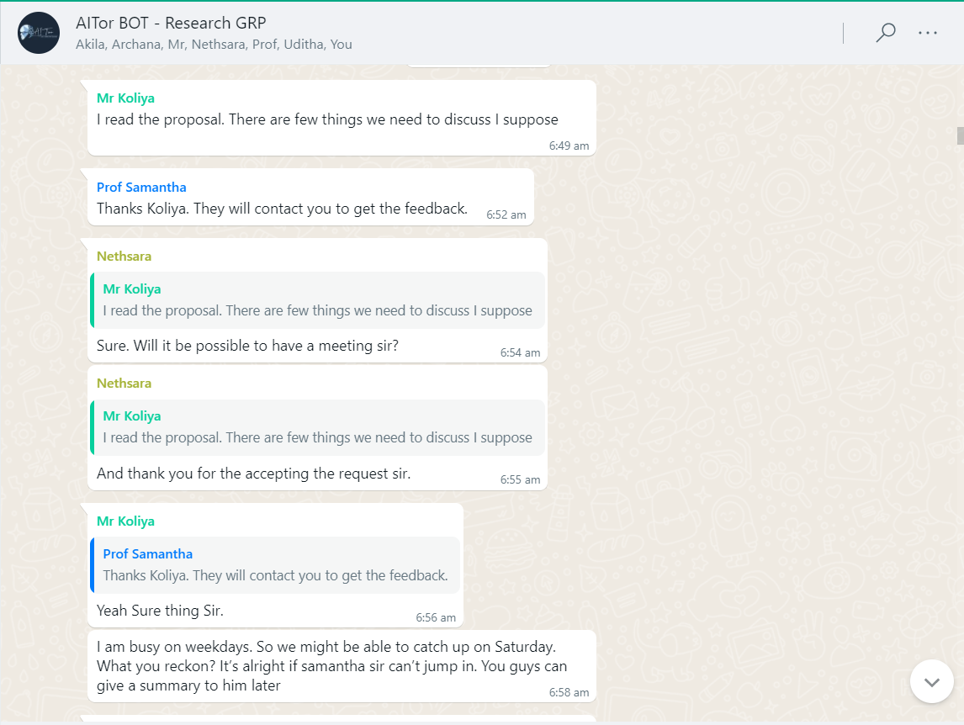

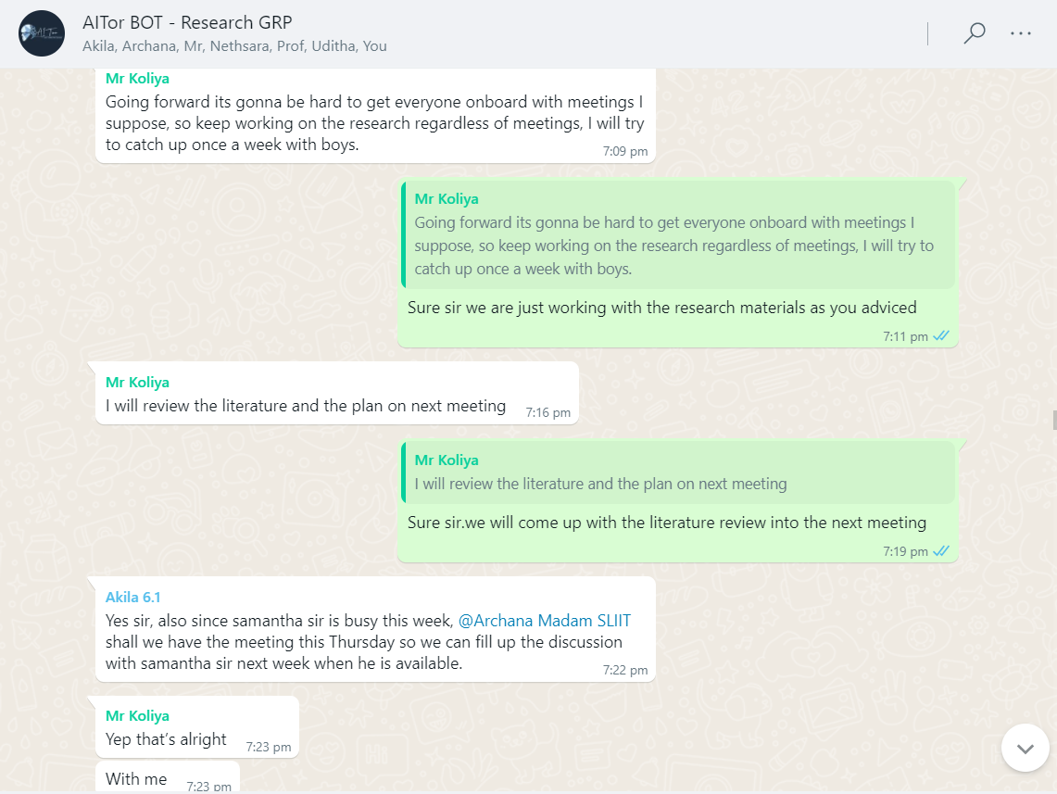

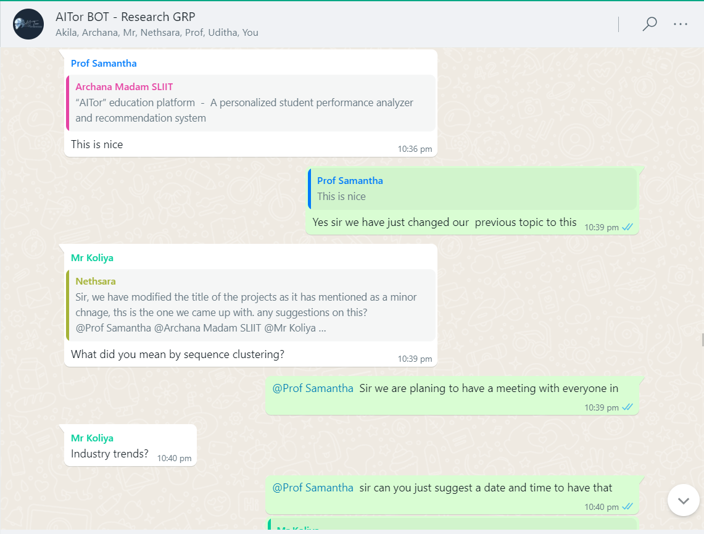

# Scheduled MS Teams discussions

## Weekly meeting with team members

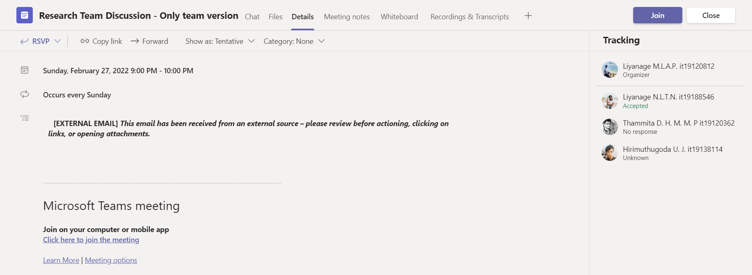

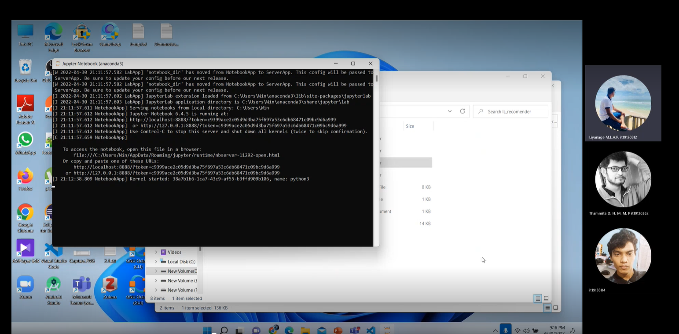

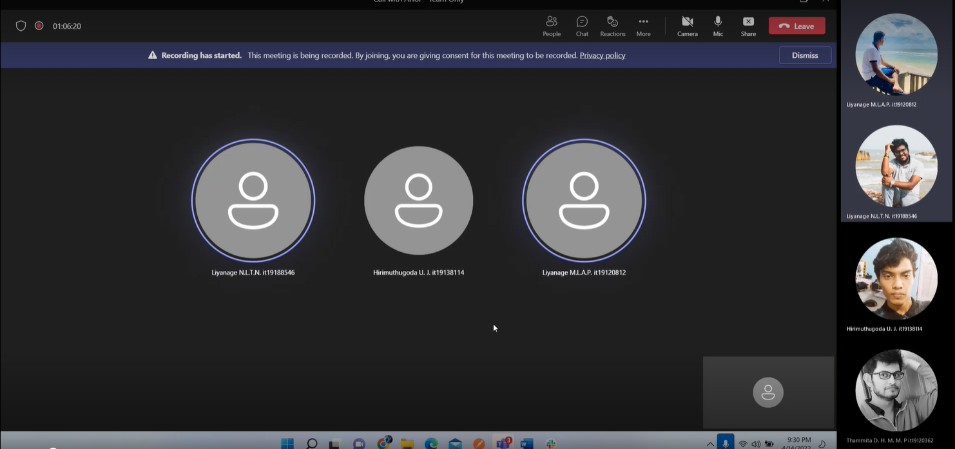

## Bi-Weekly meeting with Co-Supervisor/External-Supervisor for research progress evaluation

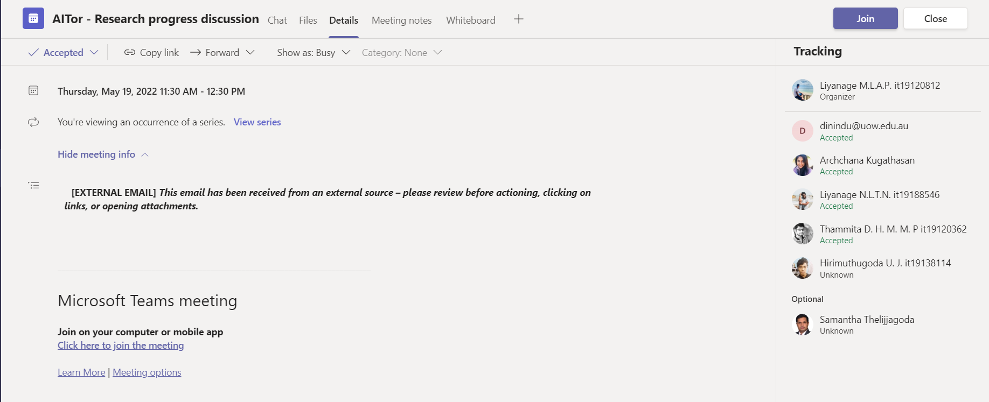

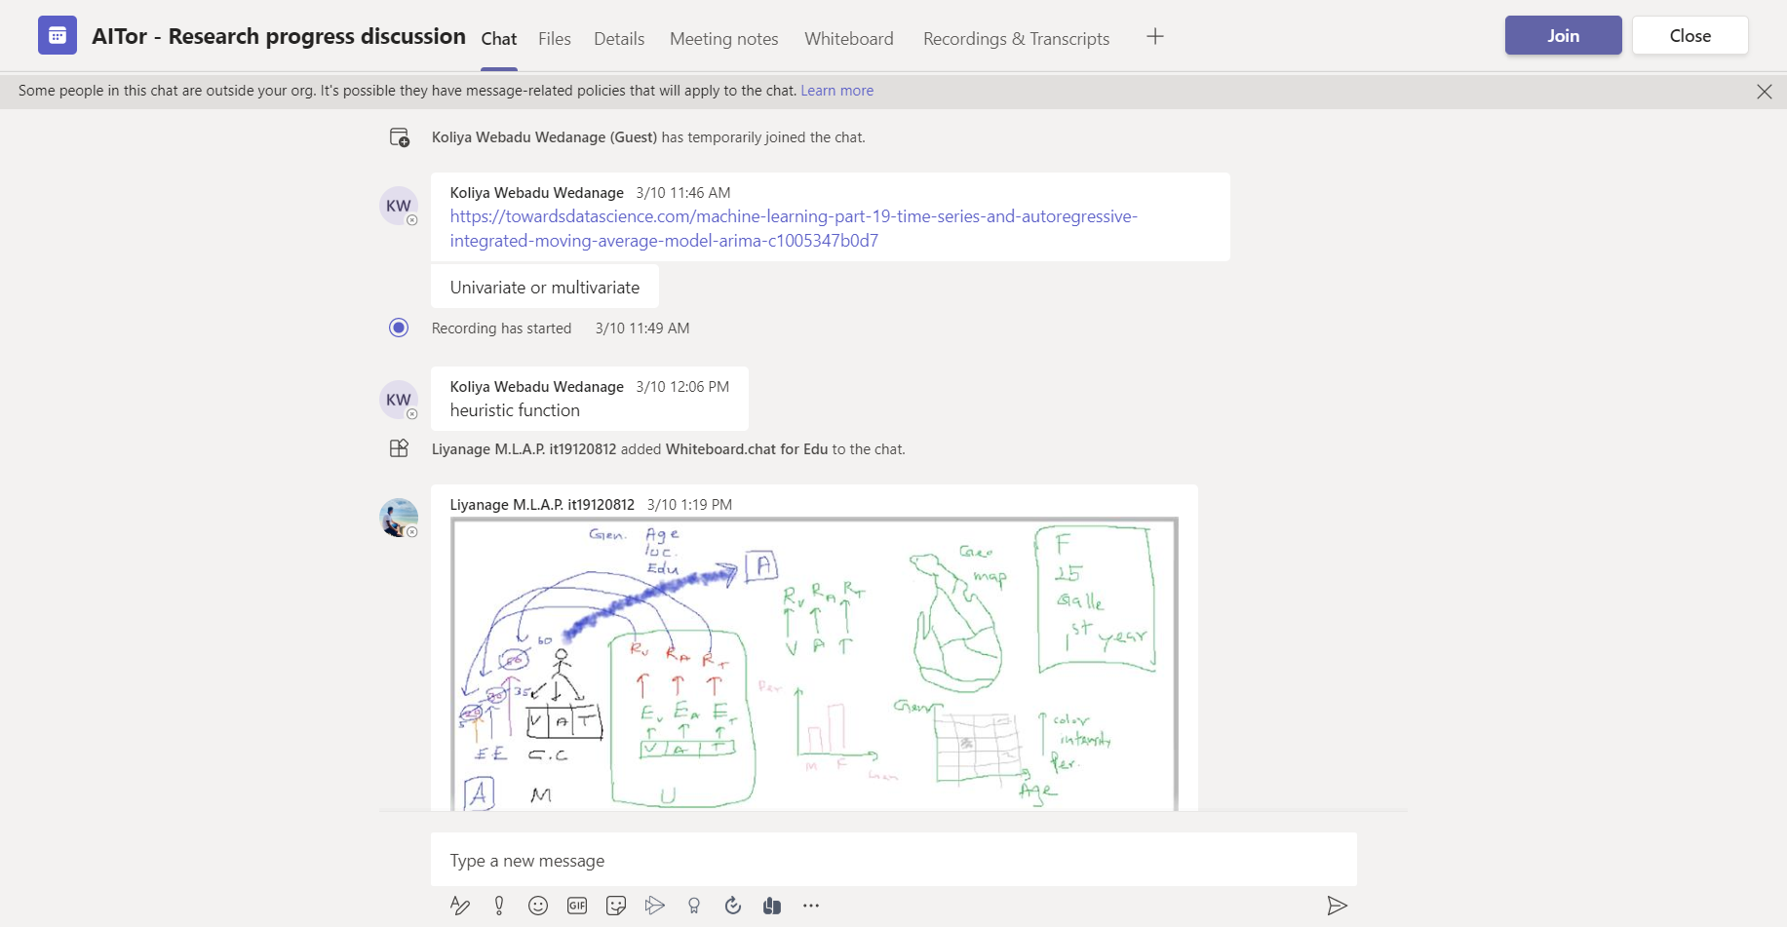

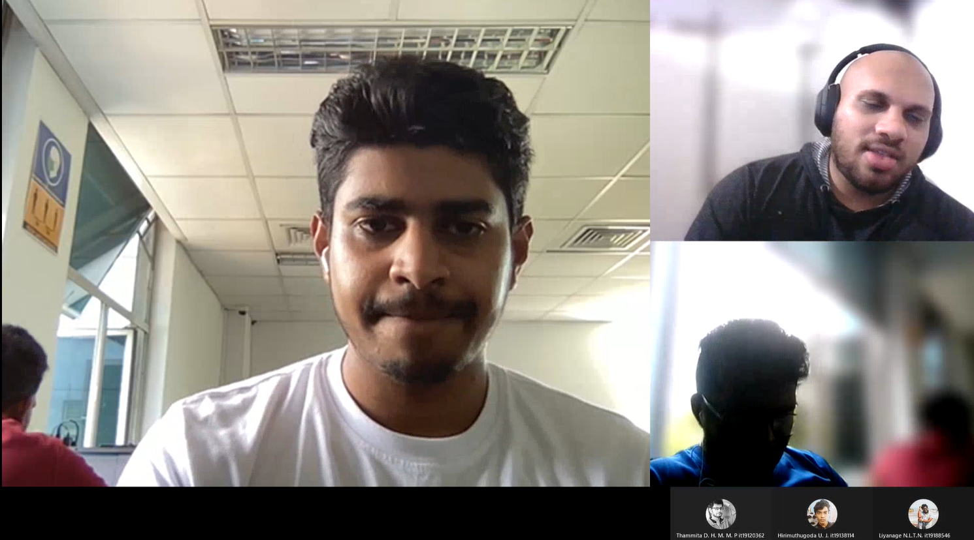

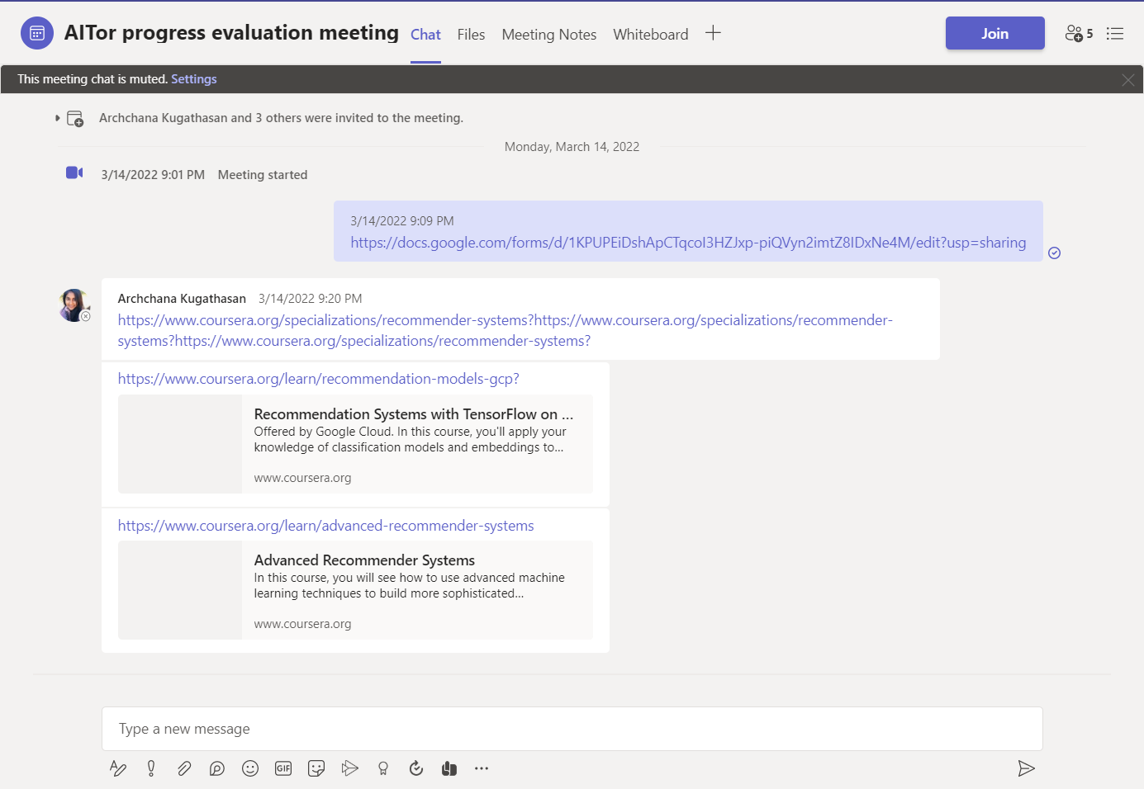

# Research Paper Presentations

## IEEE UEMCON 2022

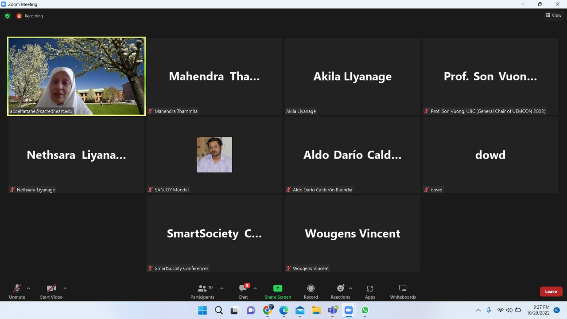

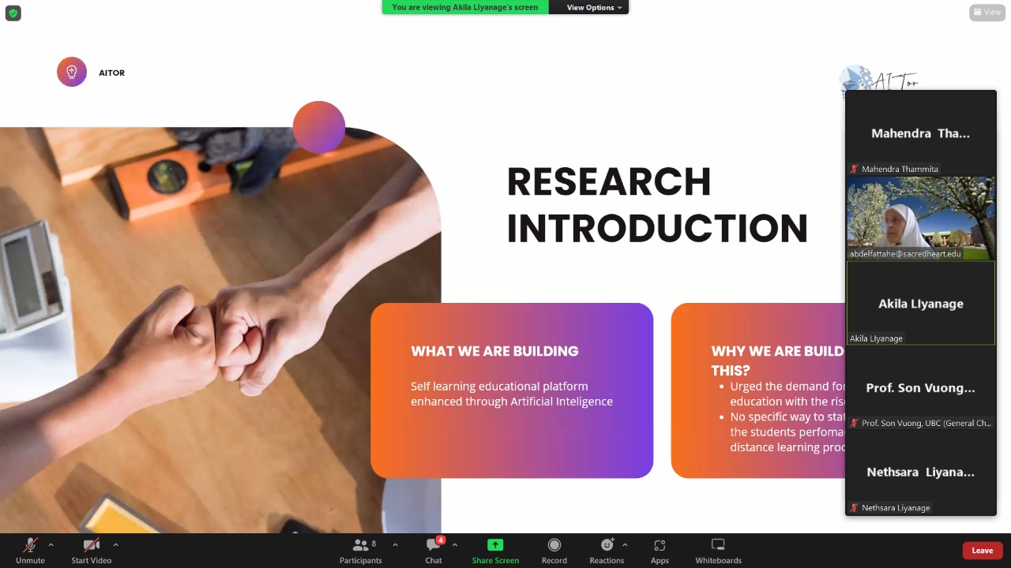

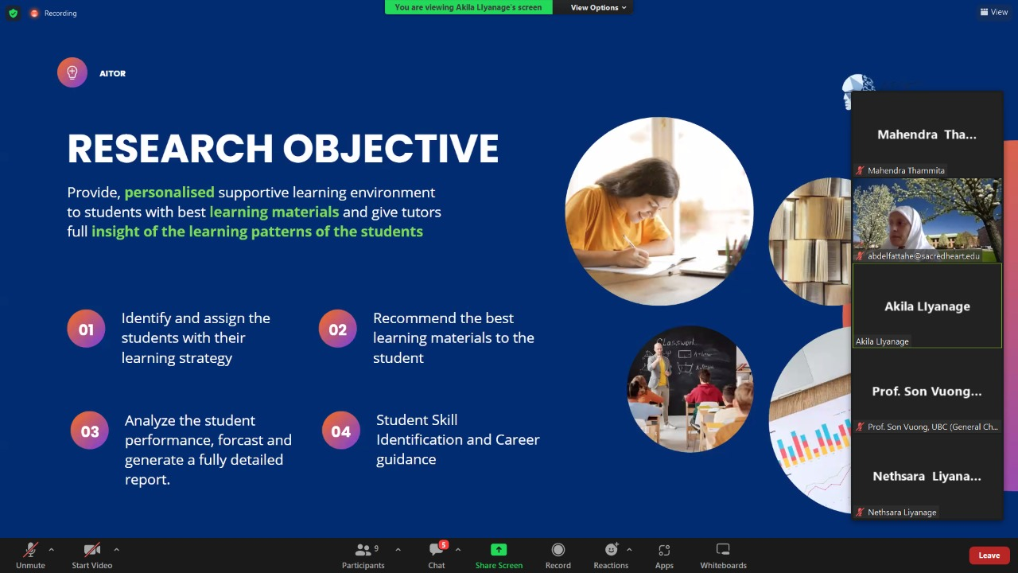

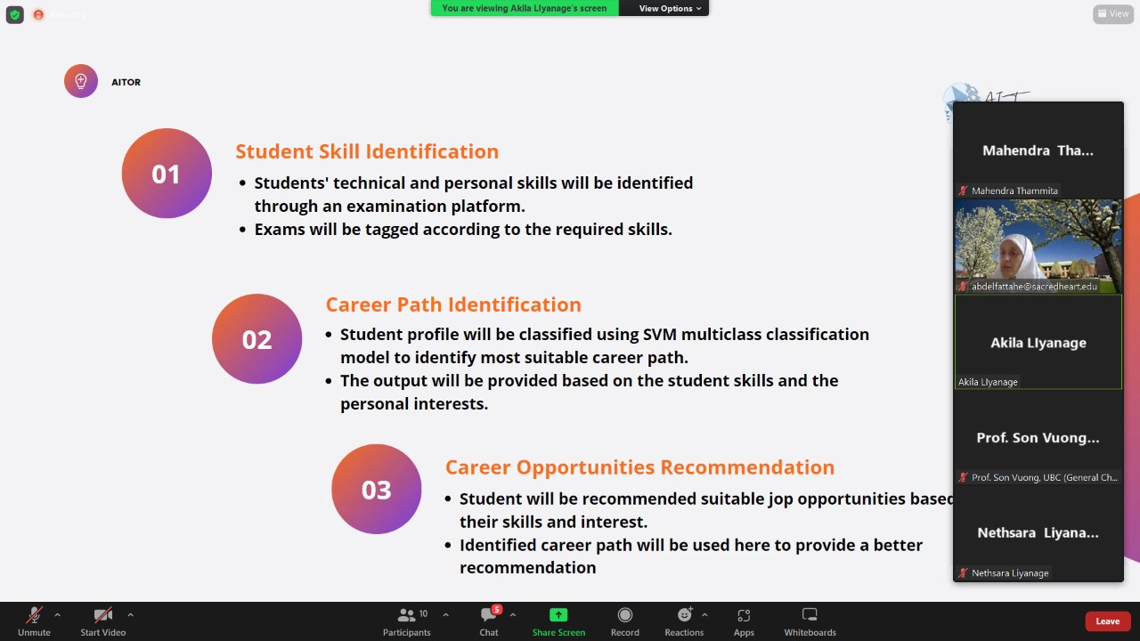

# Project planner

## Boards

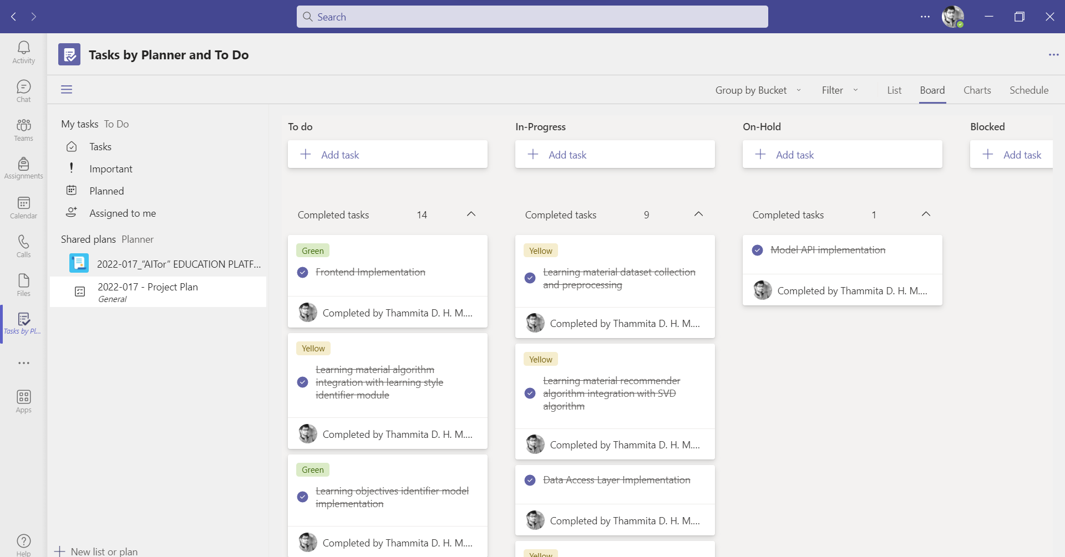

: Teams Planner Board : Grouped By Bucket

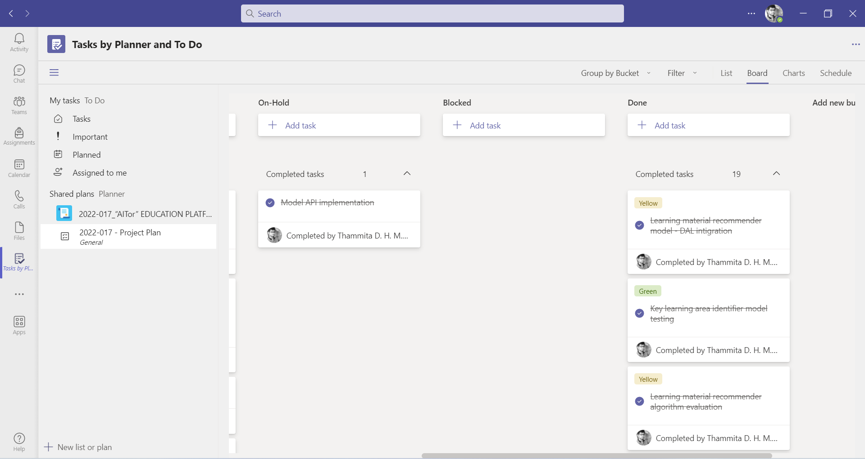

:Teams Planner Board : Grouped By Bucket - Completed

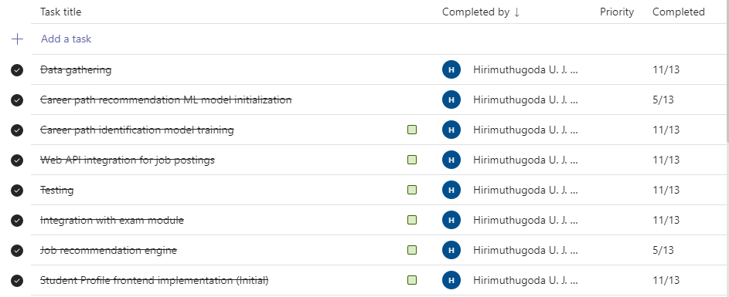

: Teams Planner Board : Completed Task List

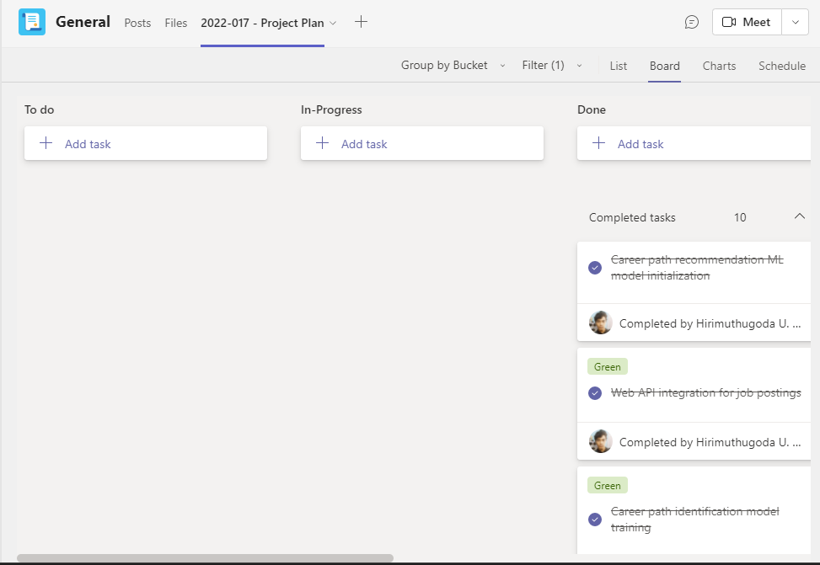

:Teams Planner Board : Completed Task List - Filter By Name – Hirimuthugoda UJ

## Charts

### Overall Project Task Overview

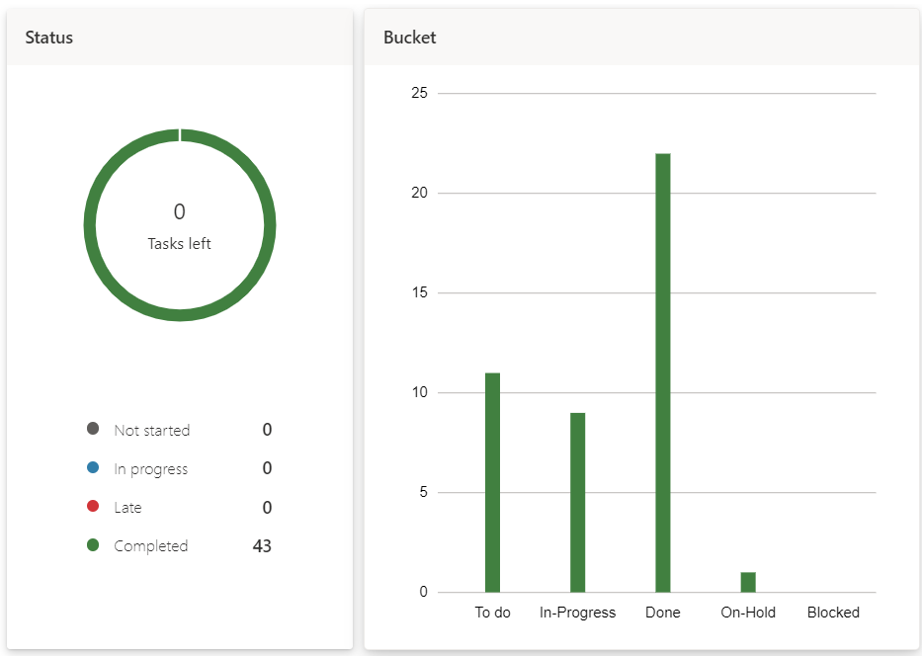

: Overall Project Task Overview - By Status and Bucket

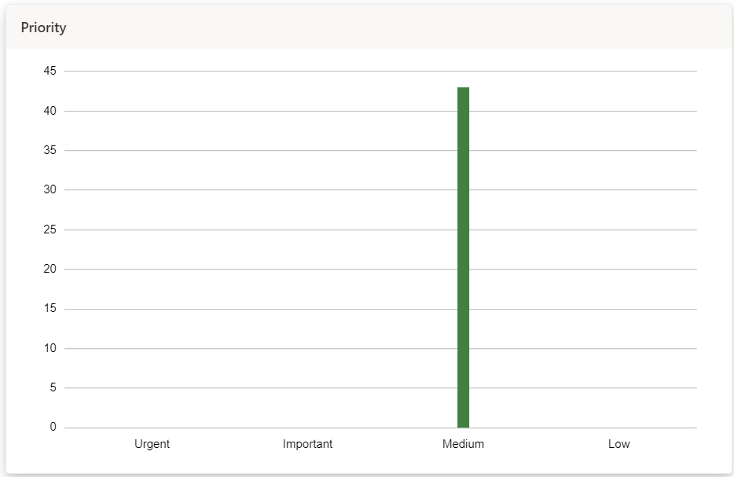

:Overall Project Task Overview - By Priority

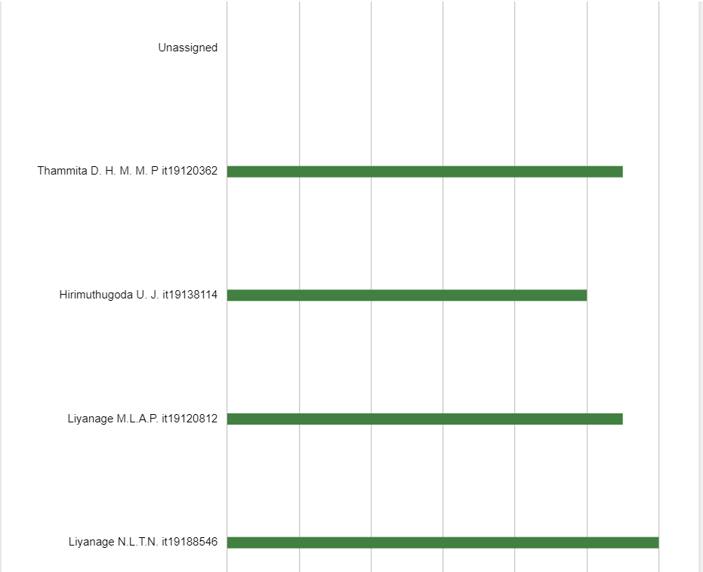

:Overall Project Task Overview - By Member

### Overview of Tasks Of Hirimuthugoda UJ (IT19138114)

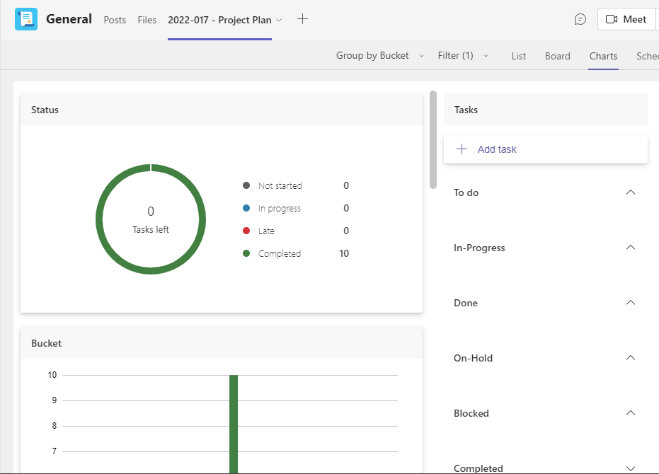

: 5.2.2. Overview of Tasks Of Hirimuthugoda UJ

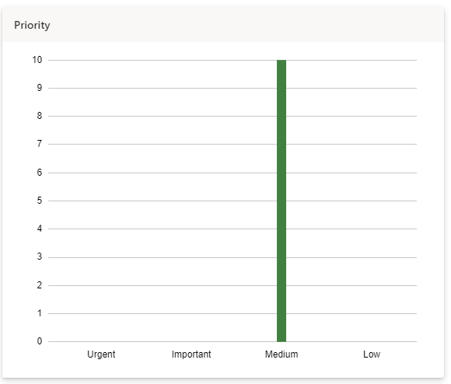

:Overview of Tasks of Hirimuthugoda UJ - By Priority

# Project Gantt chart

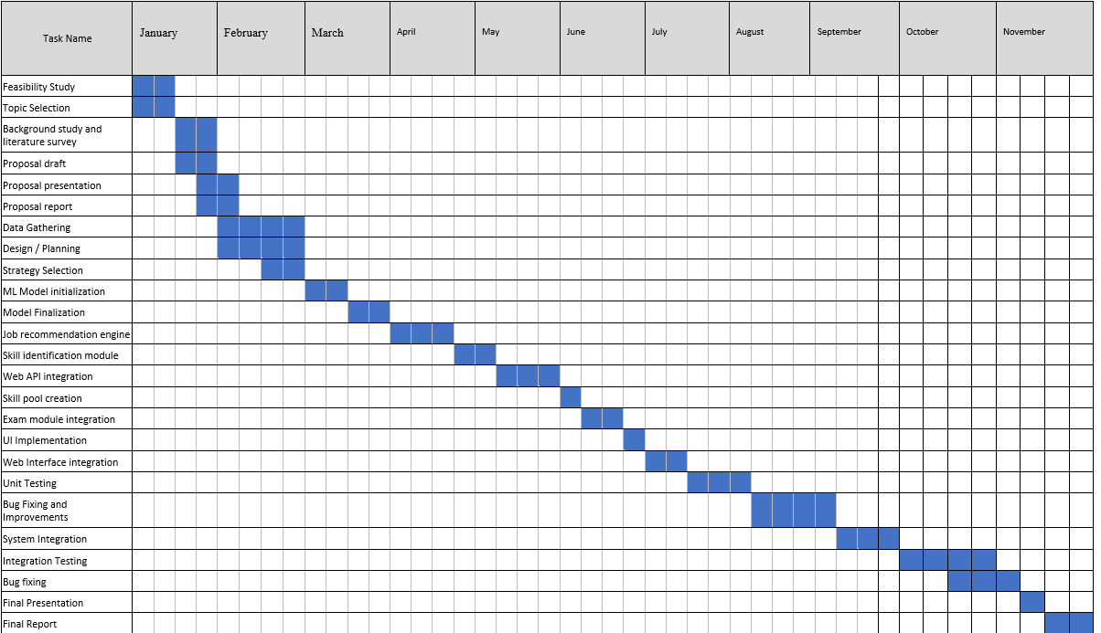

# Work breakdown chart

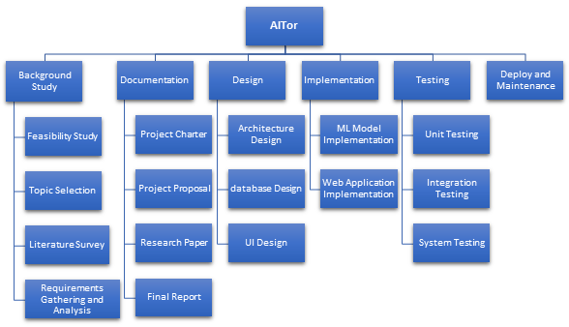

# User task allocation details

|  |  |  |
| --- | --- | --- |
| Allocated task | Predicted time | Actual time spent |
| Career paths and required skills Dataset creation | 01/04/2022 – 30/04/2022 (30 days) | 20 days |
| Career path recommendation model implementation | 15/04/2022 – 30/04/2022 (10 days) | 18 days |
| Career path recommendation API implementation | 01/05/2022 – 06/05/2022 (5 days) | 2 day |
| Job opportunity recommendation engine implementation | 30/04/2022 – 11/05/2022 (10 days) | 8 days |
| Skill extraction algorithm implementation | 05/04/2022 – 05/04/2022 (10 days) | 9 days |
| Career path identification model - DAL integration | 25/06/2022 – 30/06/2022 (5 days) | 2 days |
| Student skill identification module implementation | 30/06/2022 – 15/07/2022 (15 days) | 12days |
| skill identification module, career path identification module and job opportunity recommendation module integration | 01/06/2022 – 01/07/2022 (30 days) | 30 days |
| career path identification model evaluation | 20/07/2022 – 31/07/2022 (21 days) | 25 days |
| Frontend Implementation | 15/07/2022 – 30/08/2022 (45 days) | 40 days |
| Unit Testing | 15/08/2022 – 30/08/2022 (15 days) | 16 Days |
| Overall System Integration | 01/09/2022 – 20/09/2022 (20 days) | 30 days |

# GitLab Charts

## Commits To Master Branch

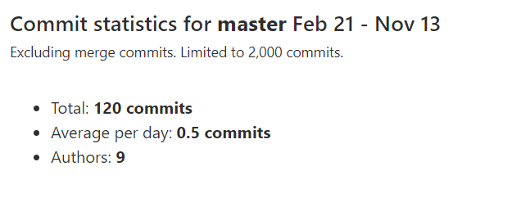

: Commit Statistics for Master Branch (Feb 21 - Nov 13)

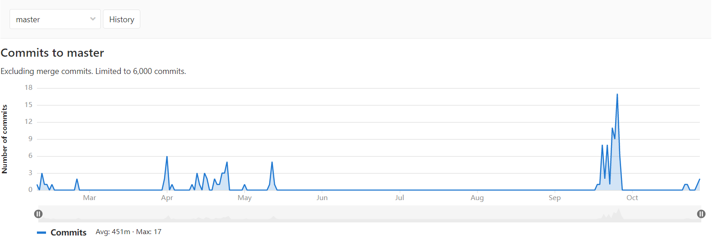

: Commits to Master Branch (Feb 21 - Nov 13)

## Commits By Hirimuthugoda UJ

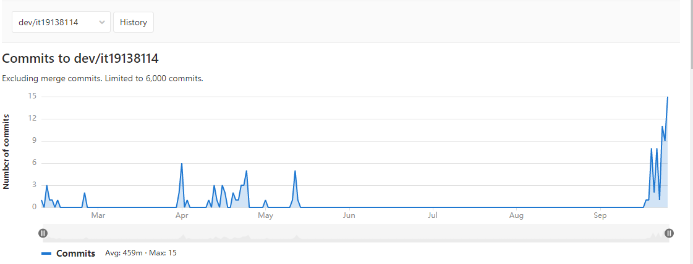

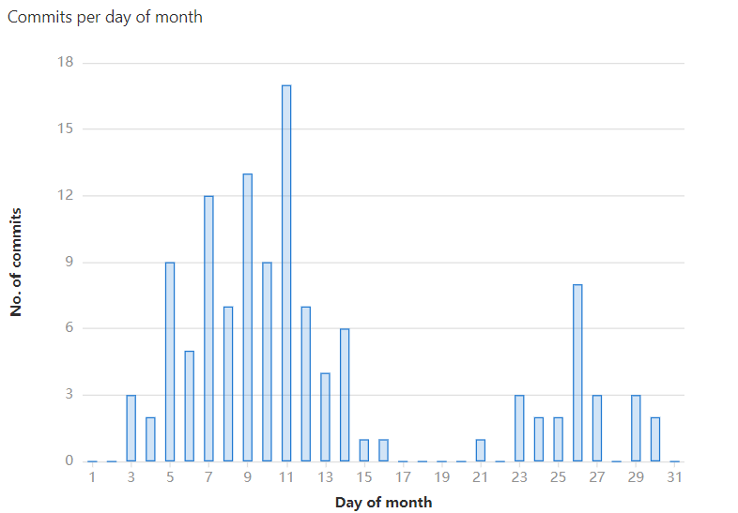

: 9:2 Commits Per Day of Month to Master Branch (Feb 21 - Nov 13)

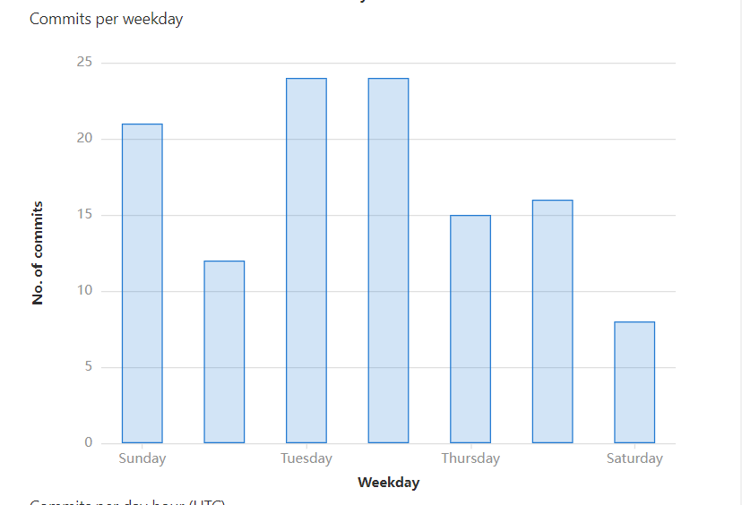

:Commits Per Weekday to Master Branch (Feb 21 - Nov 13)

## Commits To dev/it19138114

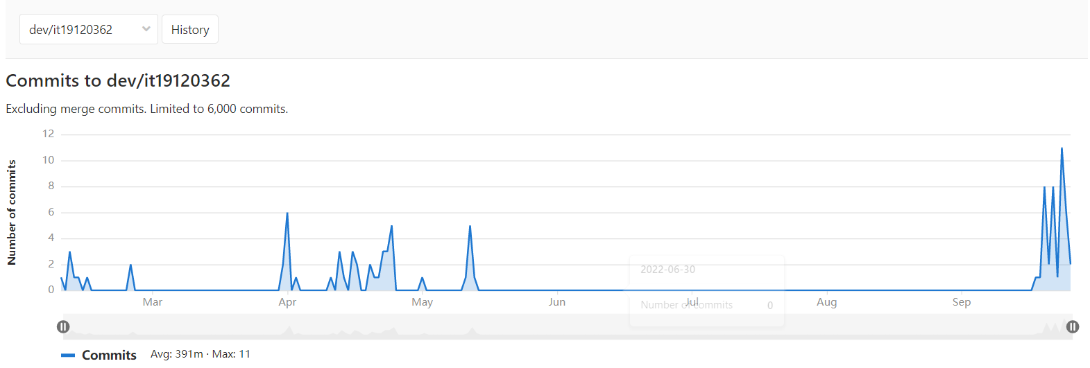

: Commits to dev/it19138114 Branch (Feb 21 - Nov 13)

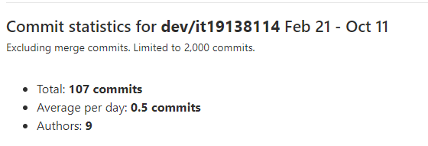

:9:3 Commits Statistics of dev/it19138114 Branch (Feb 21 - Nov 13)